**c-gvrl**

**PILOT’s OPERATING HANDBOOK**

Revision D1, December 2017

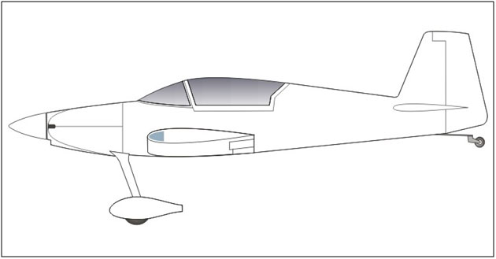

Registration: **C-GVRL**Country of Registration: **Canada**  
Make: **Vernon Little**  
Model: **Harmon Rocket II**  
Serial Number**: 4325-251**  
Certification Category: **Amateur Built**

ICAO Designation **HRO****C**

Contents

Introduction 1

1 Aircraft General Data 2

1.1 Engine 2

1.2 Propeller 2

1.3 Airframe 2

1.4 Oil 3

1.5 Grease and Fluids 4

1.6 Wheels, Brakes and Tires 4

1.7 Ignition System 5

1.8 Electrical Items 5

1.9 Maximum Weights 6

1.10 Specific Loadings 6

2 Operating Limitations 7

2.1 Symbols, Abbreviations and Terminology 7

2.1.1 Airspeed Terminology 7

2.1.2 Weight and Balance Terminology 8

2.2 Airspeed Limitations 9

2.3 Other Airspeeds (KIAS) 9

2.4 Stalling Speeds (KIAS) 9

2.5 Angle of Attack Stall Warning 9

2.6 Airspeed Indicator Markings (KIAS) 10

2.7 Maneuver Limits 10

2.7.1 Normal Operations 10

2.7.2 Flight Load Factor Limits 10

2.7.3 Aerobatic Maneuvers 10

2.7.4 Aerobatic Maneuvers-recommended entry speeds 10

2.7.5 aerobatic Maneuvers Prohibited 11

2.8 Crosswind Component Limits 11

2.9 Kinds of Operation Limits 11

3 Power Plant Limits (ref: TCDS NUMBER IE4, REVISION 22) 11

3.1 Power and Temperature 11

3.2 Oil Pressure 12

3.3 Oil Temperature 12

3.4 Fuel Pressure 12

3.5 Propeller 12

3.6 Power Plant Instrument Markings and Limits 13

4 Weight and Balance Limits 14

4.1 Weight 14

4.2 Baggage Compartment Loading 14

4.3 Datum 14

4.4 Center of Gravity 14

5 Fuel System Limits 14

6 Mandatory Instrument & Equipment 15

7 Placards 16

8 Performance 17

8.1 Strip Length Requirements 17

9 Loading Data 17

*10* *Electrical Systems Operational Limitations* 18

10.1 Electrical Power 18

10.2 Starting System 18

10.3 Radio Systems 18

11 Engine Fuel and Power Chart 19

12 Instrument and Auxiliary Panel Functions 20

12.1 Audio and Data Port Pin Assignments 23

12.2 Main Breaker Panel 24

12.2.1 Master Bus 24

12.2.2 Avionics Bus 25

12.2.3 Essential (Ignition) Bus 25

12.3 Left Rear Auxiliary Panel Function 26

12.4 Right Rear Auxiliary Panel Function 27

12.5 Throttle Quadrant 28

12.6 auto Trim/Flaps control Switch & indicator 29

12.7 Oxygen System 31

12.8 Document Storage 32

13 Control Stick Functions 33

13.1 Pilot Control Stick and Other Functions 33

13.2 Passenger Control Stick 34

13.3 Passenger Throttle, Trim and Rudder Controls 34

14 Emergency Harnesses (Seatbelts) 34

15 Engine Starting Procedure 35

15.1 Cold Starts 35

15.2 Hot Starts 35

A1 Emergency Procedures 36

A1.1 Airspeeds for Emergency Operations (KIAS) 36

A1.2 Emergency Egress 36

A1.3 Alternator Failure 37

A1.4 Electrical System Loads 37

A1.5 Emergency Procedure Checklists 38

# Introduction

This Flight Manual applies only to Harmon Rocket ***C-GVRL*** serial number ***4325-251*** and contains the airworthiness limitations and essential operating data for that aircraft. For operating information not included in this manual, reference should be made to the appropriate kit manufacturers' information, specifically the Vans’s Aircraft Inc. RV-4, and the Harmon Rocket LLC Harmon Rocket II for airframe information and the operation guides for the various avionics instrument manufacturers.

# 1 Aircraft General Data

## 1.1 Engine

Manufacturer: Lycoming/Aero Sport Power.  
Type: IO-540-D4A5 with 9.2:1 compression ratio pistons.

Horsepower: 260 BHP (194 kW) @ 2700 rpm nominal rated.

Fuel: 100LL Avgas only.

## 1.2 Propeller

Manufacturer: Hartzell   
Model: DHC-M2YR-1BFPX/F8068DX*1/SM8  
Number of Blades: 2  
Nominal Diameter: 80” 2.03 m  
Type: Constant Speed, Variable Pitch

## 1.3 Airframe

Wingspan 21’10” 6.65 m

Length 21’6” 6.55 m

Height 5’7” 1.70 m

Wheel Track 6’6” 1.98 m

## 1.4 Oil

***Specification: MIL-L-6082/*SAE-J-1966 *Aviation Grade Straight non-AD Mineral Oil***

**Ambient Air Temperatures Viscosity Grades**

Above 16 °C SAE 50  
-1 to 32 °C SAE 40  
-18 to 21 °C SAE 30  
Below -12 °C SAE 20

***Specification: MIL-L-22851/*SAE-J1899 *Aviation Grade Ashless Dispersant Oil***

**Ambient Air Temperatures Viscosity Grades**

Above 16 °C SAE 40 or SAE 50

-1 to 32 °C SAE 40

-18 to 21 °C SAE 30 or SAE 40

Below -12 °C SAE 30

All temperatures 15W50 (AeroShell Synthetic) or 20W50 (Phillips Mineral) multigrade

As-flown 20W50 Phillips multigrade, with up to 10% 20W50 Phillips Anti-Rust oil for seldom-flown winter operations. 9 quarts indicated sump level.

***Capacities:***

Sump 12 USQ 11.36 L

Usable 9.25 USQ 8.75 L

30 ° Up or Down 8.0 USQ 7.6 L

Oil Filter 1 USQ 0.95 L

Recommended Oil Filter Model:Champion CH48110-1 or Tempest AA48110-2

**Note: Oil dipstick indicates 1.5 USQ low when aircraft is in 3-point stance.**

## 1.5 Grease and Fluids

Wheel Bearing and general purpose grease: AeroShell #22 grease

Propeller grease: AeroShell #6 grease. Do not substitute.

Brake Hydraulic Fluid MIL-PRF-5606H

K&N air filter recharge kit K&N 995050

## 1.6 Wheels, Brakes and Tires

**Brake Caliper** Grove 31-3M

**Brake Lining** Grove 066-111 or 066-111K (kit of four with rivets)

**Wheels** Grove 56-1M

**Tires** Desser 500-5 AWBS 6 PLY Retread

**Tubes** Leak Guard Tube 500 x 5

**Tail Wheel** Van’s Aircraft U TAIL WHEEL 6

## 1.7 Ignition System

***C-GVRL*** is equipped with one Slick impulse-coupled magneto, designated as the Left ignition, and one Electroair electronic ignition, designated as the Right ignition. The electronic ignition fires the bottom spark plugs. Both ignitions should be ON for engine starting.

**Ignition Timing:**

Left Magneto 20 °BTDC, set by magneto rotation.

Right Electronic 20 °BTDC, set by internal adjustment on ignition controller with engine running and IGN ADVANCE switch OFF.

**Variable Timing:**

The Right Electronic Ignition is capable of automatic timing advance depending on manifold air pressure (MAP) and engine speed (RPM). Automatic advance is controlled by the IGN ADVANCE switch on the instrument panel. Selecting the switch OFF will disable the automatic advance function of the ignition. It is recommended that the switch be selected OFF during engine break-in or if cylinder head temperatures are high.

**Spark Plugs** Model Gap

Top (magneto): REM37BY 0.016-0.021”

Bottom (electronic ignition): REM37BY 0.030-0.035”

## 1.8 Electrical Items

**Main Battery:** Odyssey PC-925 or PC925L. Replace on condition. Observe reversed terminal polarity between the two versions of the Odyssey battery.

**Ignition Battery:** BB Battery BP1.2-12-T1. Replace on condition.

**ELT Remote Control Panel Indicator:**

Duracell PX28L 6 volt Lithium battery, or equivalent, 10 year replacement; or

Eveready A544 or equivalent battery, 5 year replacement.

**ELT Audio Alert Indicator:**

Duracell CR-2, 3 volt or equivalent battery. Replace every 10 years.

**ELT Main Battery:**

ACK 406 E-04 part# 11-10012. Replace every 5 years.

**SkyView SV-D1000 EFIS:**

SV-BAT-320. On Condition, tested annually or when indicated on EFIS display.

## 1.9 Maximum Weights

Takeoff All Categories 2000 lbs. 907 kgf

Landing All Categories 2000 lbs. 907 kgf

Operating Aerobatic Category 1800 lbs. 818 kgf

Rear Seat 250 lbs. 113.4 kgf

Baggage Compartment Floor 100 lbs. 45.4 kgf

Shelf 15 lbs. 6.8 kgf

## 1.10 Specific Loadings

Gross Wing Area 109 sq.ft. 10.13 m2

One Flap Area 4.5 sq.ft. 0.42 m2

Flap Deflection 40 °

Maximum Wing Loading 18.35 lb/sq.ft. 89.59 kgf/m2

Maximum Power Loading 7.69 lb/hp 4.68 kgf/kW

# 2 Operating Limitations

## 2.1 Symbols, Abbreviations and Terminology

### 2.1.1 Airspeed Terminology

**KCAS** **Knots Calibrated Airspeed** is indicated airspeed corrected for position and instrument error and expressed in knots. Knots calibrated airspeed is equal to KTAS in standard atmosphere at sea level.

**KIAS Knots Indicated Airspeed** is the speed shown on the airspeed indicator and expressed in knots.

**KTAS Knots True Airspeed** is the airspeed expressed in knots relative to undisturbed air which is KCAS corrected for altitude and temperature.

**VA  Maneuvering Speed** is the maximum speed at which you may use abrupt elevator control travel.

**VFE Maximum Flaps Extended Speed** is the highest speed permissible with the wings flaps in the maximum extended position.

**VNO Maximum Structural Cruising Speed** is the speed that should not be exceeded except in smooth air, then only with caution.

**VNE Never Exceed Speed** is the speed limit that may not be exceeded at any time.

**VS Stalling Speed** or the minimum steady flight speed at which the airplane is controllable.

**VS0 Stalling Speed** or the minimum steady flight speed at which the airplane is controllable in the landing configuration.

**VX Best Angle of Climb Speed** is the speed which results in the greatest gain of altitude in a given horizontal distance.

**VY Best Rate of Climb Speed** is the speed which results in the greatest gain of altitude in a given time.

### 2.1.2 Weight and Balance Terminology

**Reference Datum Reference Datum** is an imaginary vertical plane from which all horizontal distances are measured for balance purposes.

**Station Station** is a location along the airplane fuselage given in terms of the distance from the reference datum.

**Arm Arm** is the horizontal distance from the reference datum to the center of gravity (C.G.) of an item.

**Moment Moment** is the product of the weight of an item multiplied by its arm.

**Center of Gravity (C.G.) Center of Gravity** is the point at which an airplane or equipment would balance if suspended. Its distance from the reference datum is found by dividing the total moment by the total weight of the airplane.

**C.G. Arm Center of Gravity Arm** is the arm obtained by adding the airplane’s individual moments and dividing the sum by the total weight.

**C.G. Limits Center of Gravity Limits** are the extreme center of gravity locations within which the airplane must be operated at a given weight.

**Standard Empty Weight Standard Empty Weight** is the weight of a standard airplane, including unusable fuel, full operating fluids and full usable engine oil.

**Basic Empty Weight Basic Empty Weight** is the standard empty weight plus the weight of optional equipment.

**Useful Load Useful Load** is the difference between takeoff weight and the basic empty weight.

**Gross (Loaded) Weight Gross (Loaded) Weight** is the loaded weight of the airplane.

**Maximum Takeoff Weight Maximum Takeoff Weight** is the maximum weight approved for the start of the takeoff run

**Maximum Landing Weight Maximum Landing Weight** is the maximum weight approved landing touchdown.

**Tare Tare** is the weight fo chocks, blocks, stands, etc. used when weighing an airplane and is included in the scale readings. Tare is deducted from the scale reading to obtain actual (net) airplane weight.

## 2.2 Airspeed Limitations

**VNE Never Exceed Speed** 240 KTAS Do not exceed this speed in any operation

**VNO Maximum Structural** 160 KIAS Do not exceed this speed except in smooth air, and then only with caution.

**VA  Maneuvering** 125 KIAS Do not make full or abrupt control movements above this speed.

**VFE Maximum flaps extended** 95 KIAS Do not exceed this speed with flaps down.

## 2.3 Other Airspeeds (KIAS)

**No VGs With VGs**

**VH Maximum Sea Level Speed** 215 215

**VX Best Angle of Climb** 74 74

**VY Best Rate of Climb** 91 91

**VEC Enroute Climb** 91-122 91-122

**VS0 Stall, 40** ° **of Flaps** 58 55

**VS1 Stall, 15** ° **of Flaps** 58 58

**VS Stall, Clean** 61 60

**VBG Best Glide** 87 87

**VLOF Lift Off** 60-70 60-70 0 ° Flaps

**VREF Final Approach** 78 74 15° Flaps

74 70 40 ° Flaps

**Short Field Final Approach** 68 65 40 ° Flaps

## 2.4 Stalling Speeds (KIAS)

**Flaps Stalling Speeds - Power Off**

**No VGs With VGs**

2000 lbs. 1800 lbs. 2000 lbs. 1800 lbs.

**0** ° **VS** 61 60 60 59   
**20** ° **VS1** 58 57 58 57   
**40** ° **VS0** 58 57 55 54

## 2.5 Angle of Attack Stall Warning

The aircraft is equipped with an Angle Of Attack warning audio and visual indication that requires calibration by the pilot during initial flight test operations and when any aerodynamic changes are made, such as the installation or removal of vortex generators (VGs)

## 2.6 Airspeed Indicator Markings (KIAS)

**No VGs With VGs**

**White Tape 58-95 55-95**  Full Flap Operating Range. Lower limit is maximum weight VS0 in landing configuration. Upper limit is maximum speed permissible with flaps extended.

**Green Tape 61-160 60-160**  Normal Operating Range. Lower limit is maximum weight VS at most forward C.G. with flaps retracted. Upper limit is maximum structural cruising speed.

**Yellow Tape 160-240 160-240**  Operations must be conducted with caution and only in smooth air.

**Red Line 240 240**  Maximum speed for all operations. Note that this is true airspeed which is indicated airspeed corrected for pressure altitude and air temperature.

## 2.7 Maneuver Limits

This section contains essential information relating to the handling characteristics and operation of the aircraft and its systems.

### 2.7.1 Normal Operations

Operations at up to maximum take-off weight are limited to normal flying maneuvers but may include straight and steady stalls, and turns in which the angle of bank does not exceed 60 °. Spins are permitted.

### 2.7.2 Flight Load Factor Limits

Flight Load Factors at Gross Weight +6.0g -3.0g

### 2.7.3 Aerobatic Maneuvers

**Aerobatic Maneuvers are prohibited unless explicitly allowed in the aircraft Certificate of Airworthiness. Notwithstanding this prohibition, the aircraft is capable of aerobatic maneuvers subject to the following:**

* Aircraft weight not to exceed the Operating, Aerobatic Category Limit.
* G loads not to exceed the Flight Load Factor Limits.
* Aft C of G limit not to exceed the Rear Limit, Aft of Datum (Aerobatic)
* Due to limited inverted oil capacity, all inverted or negative maneuvers are limited to 6 seconds for every minute of flight. Only the **RIGHT** wing fuel tank is configured for inverted flight.
* Canopy ejector ramps must be installed when a parachute is worn.

### 2.7.4 Aerobatic Maneuvers-recommended entry speeds

**Maneuver Entry Speed Range**

Inside loops & horizontal eights 121-165 KIAS

Chandelles, wingovers (Immelmans) 130-165 KIAS

Aileron rolls, barrel rolls 105-165 KIAS

Flick rolls (snap rolls) 70-95 KIAS

Vertical rolls 156-165 KIAS

Split-S turns 86-95 KIAS

### 2.7.5 aerobatic Maneuvers Prohibited

* Tail slides
* Flick rolls (snap rolls) initiated in excess of 95 KIAS

## 2.8 Crosswind Component Limits

The maximum demonstrated crosswind component for take-off and landing is 15 knots.

## 2.9 Kinds of Operation Limits

The aircraft is equipped for VFR and is capable of VFR day, VFR night and VFR OTT operations. It is equipped with a heated pitot tube and an alternate static source valve. Flight into know icing conditions is prohibited.

# 3 Power Plant Limits (ref: TCDS NUMBER IE4, REVISION 22)

## 3.1 Power and Temperature

**Engine Manufacturer/Model: Avco Lycoming IO-540-D4A5**

**Power RPM MAP CHT Oil T**   
Max. Take Off and Continuous Power 2700 FULL THROTTLE 500 °F 245 °F   
(260 bhp) 260 °C 118 °C

Note:

* At all power settings above 65%, mixture controls may be used only to the extent necessary to avoid rough running which would otherwise result from an over rich mixture.
* For maximum engine longevity, it is highly recommended that CHT not exceed 390 °F (199 °C) and that Oil T not exceed 200 °F (93 °C).
* The aircraft is equipped with a Ram Air control located on the left side of the instrument panel. This control must be pushed in for filtered air below 8000 feet or in precipitation or dust at any altitude. For higher altitudes in clear conditions, this control may be pulled out to increase manifold pressure and horsepower.
* The aircraft is equipped with a pilot-controlled oil cooler shutter control located on the right side of the instrument panel. This control should be pushed in to ensure maximum cooling air through the oil cooler and pulled out to minimize the cooling air flow and maximize oil temperature during winter operations.
* An engine oil reservoir is provided that allows short-term inverted flight with minimal oil spillage.

## 3.2 Oil Pressure

Normal 55-95 psi. 414-620 kPa   
Minimum safe idling 25 psi. 172 kPa   
Start, warm-up, taxi, take-off 115 psi. 893 kPa

## 3.3 Oil Temperature

Minimum for take-off power: Temperature at which the engine idles properly and is responsive to the throttle without stumbling or roughness. Maximum temperature is 245 °F or 118 °C

## 3.4 Fuel Pressure

Normal 14-45 psi. 96-310 kPa  
Minimum Idle/Maximum Idle Cut-Off 12/55 psi. 83-379 kPa

## 3.5 Propeller

**Manufacturer: Hartzell**Model: DHC-M2YR-1BFPX/F8068DX*1/SM8  
Number of Blades: 2

Diameter:

Minimum 78” 1.981 m

Maximum 80” 2.032 m

## 3.6 Power Plant Instrument Markings and Limits

|  |  |  |  |  |  |
| --- | --- | --- | --- | --- | --- |
| **INSTRUMENT** | **RED LINE**  **MINIMUM** | **YELLOW ARC**  **CAUTION RANGE** | **GREEN ARC**  **NORMAL OPERATING** | **YELLOW ARC**  **CAUTION RANGE** | **RED LINE**  **MAXIMUM LIMIT** |
| **Tachometer** | none | none | 2200-2700 RPM | none | 2700 RPM |
| **Manifold Air Pressure** | none | none | 10-35 inHg 339-1185 hPa | none | 35 inHg 1185 hPa |
| **Oil Temperature** | 100 °F 38 °C | 100-165 °F 38-74 °C | 165-200 °F 74-93 °C | 200-245 °F 93-118 °C | 245 °F 118 °C |

|  |  |  |  |  |  |
| --- | --- | --- | --- | --- | --- |
| **Oil Pressure** | 25 psi 1.72 b | 25-55 psi 1.72-3.79 b | 55-95 psi 3.79-6.55 b | 95-115 psi 6.55-7.93 b | 115 psi 7.93 b |
| **Fuel Pressure** | 12 psi 0.82 b | 12-14 psi 0.82-0.97 b | 14-45 psi 0.97-3.10 b | 45-55 psi 3.10- 3.79 b | 55 psi 3.79 b |
| **Cylinder Head Temperature** | 150 °F 66 °C | 150-350 °F 66-177 °C | 350-435 °F 177-234 °C | 435-500 °F 234-260 °C | 500 °F 260 °C |

# 4 Weight and Balance Limits

## 4.1 Weight

Maximum take-off weight 2000 lb 907 kgf  
Maximum landing weight 2000 lb 907 kgf

## 4.2 Baggage Compartment Loading

(i) Maximum permissible baggage compartment load:

Floor section: 100 lbs 45 kgf  
Shelf section: 15 lbs 7 kgf

1. Where passenger seat is removed to permit the carriage of cargo, the permitted maximum load in the seat area should not exceed **250 lb (110 kgf)** plus the weight of the removed seat. The rear pilot control stick should be removed during any cargo carrying operationMaximum aerobatic weight 1800 lbs .

## 4.3 Datum

Forward of Wing Root Leading Edge: 80” 2.03 m

## 4.4 Center of Gravity

Forward limit, Aft of Datum: 88.7” 2.253 m  
Rear limit, Aft of Datum (Normal): 97.4” 2.474 m

Rear limit, Aft of Datum (Aerobatic): 95.9” 2.436 m

# 5 Fuel System Limits

Approved Grade (colour): 100 LL Avgas only (blue)  
Right tank usable capacity: 21.4 USG 81 L   
Left tank usable capacity: 21.4 USG 81 L

Prolonged uncoordinated flight with low fuel quantities may uncover the fuel tank outlets, causing fuel starvation and engine failure.

The fuel selector (located on the lower center console in front of the control stick) is a three position selector. OFF – Straight back. Left ON – Pointer to the left. Right ON – Pointer to the right. In order to switch the fuel selector to OFF or from OFF to either of the ON positions, the lever must be pulled up to disengage the lock while turning.

The Right fuel tank uses an inverted “flop tube” pickup for aerobatic operations which may hang up during certain maneuvers. If the fuel level is adequate, the Left tank should be selected for landings and takeoffs.

# 6 Mandatory Instrument & Equipment

The aircraft shall not be operated unless, in addition to the minimum flight and navigational instruments required by CAR Part VI, Subpart V, the following instruments and indicators are to be installed and serviceable:

* At least one Electronic Flight Information System (EFIS) that includes display of flight and engine instrumentation;
* At least one wet compass with current calibration card attached;
* Except where exempted, a 406 MHz Emergency Locator Transmitter (ELT).

# 7 Placards

**Regulatory Reference: Canadian Aviation Regulations (CARs) 2012-1**

Part *V - Airworthiness Manual Chapter 549 - Amateur-Built Aircraft*, Section **549.15; and**

***Exemption from Section 549.01 of the Canadian Aviation Regulations and Chapter 549 of the Airworthiness Manual-Airworthiness Standards – Amateur-Built Aircraft.***

**On instrument panel:**

“VFR ONLY”

“AEROBATIC MANEUVERS PROHIBITED”

**Legible from each passenger station, or displayed on the side of the fuselage:**

“YOU FLY IN THIS AIRCRAFT AT YOUR OWN RISK. THIS AIRCRAFT DOES NOT COMPLY WITH INTERNATIONALLY RECOGNIZED STANDARDS. VOUS VOLEZ À BORD DE CET AÉRONEF À VOS PROPRES RISQUES. CET AÉRONEF N’EST PAS CONFORME AUX NORMES RECONNUES À L’ÉCHELLE INTERNATIONALE.”

**In passenger carriage area:**

“MAXIMUM PASSENGER AND/OR BAGGAGE LOAD 250 LBS.”

**Near fuel tank filler caps**

AVGAS 100LL ONLY  
21.4 USG (81 L)

**Near the fuel selector valve**

LEFT 21.4 USG (81 L)

RIGHT 21.4 USG (81 L)

# 8 Performance

### 8.1 Strip Length Requirements

Operations should be conducted from strips of not less than 1500 feet (457 m) length plus an increase of 150 feet (46 m) for each 1,000 feet (305 m) the strip is above sea level.

# 9 Loading Data

This section contains basic weight and center of gravity (CG) information necessary to ensure correct loading of the aircraft and comprises Aircraft Weight and Loading System pages.

Use the following for Weight and Balance calculations:

Approved CG forward limit, aft of Datum: 88.7” 2.253 m   
Approved CG aft limit, aft of Datum: 97.4” 2.474 m

Approved Aerobatic CG aft limit, aft of Datum: 95.9” 2.436 m   
Approved maximum weight: 2000 lb 907.2 kgf

Approved maximum aerobatic weight 1800 lb 816.5 kgf

|  |  |  |  |  |  |
| --- | --- | --- | --- | --- | --- |
| **Item** | **Weight** | **X** | **Arm** | **=** | **Moment** |
| C-GVRL Empty, with 18 lbs (9 USQ) 10 USQ oil included (Amendment 2) | 1266 lb  (574.2 kgf) | X | 87.0” (2.210 m) | = | 110,142 lb-in (1268.0) kgf-m |
| Pilot |  | X | 108” (2.743 m) | = |  |
| Fuel |  | X | 90” 2.286 m | = |  |
| Passenger |  | X | 138” (3.505 m) | = |  |
| Baggage Floor |  | X | 159” (4.039 m) | = |  |
| Baggage Shelf |  | X | 185.5”  4.712 m | = |  |
| Totals |  |  |  |  |  |
|  |  |  |  |  |  |
| CG = Total Moment / Total Weight |  |

# *10 Electrical Systems Operational Limitations*

## 10.1 Electrical Power

***Do not turn off the alternator in flight except in an emergency.***

The aircraft is equipped with one alternator and two system batteries—one for the master electrical bus (“Main Battery”) and one for temporary powering of the electronic ignition system during engine start (“Ignition Battery”). Additional batteries are provided for the Electronic Flight Information System display (externally connected battery) and the GPS (internal battery).

All aircraft instruments are electrically controlled. The main alternator is a 60 amp unit, with internal regulation. The alternator is located on the front, right side of the engine, and is belt driven. The alternator wiring is protected by a 60 amp circuit breaker for the B-lead and a 7 amp circuit breaker for the Field circuit.

See separate Aircraft Electrical System Schematic for full diagrams and installation information.

## 10.2 Starting System

The aircraft is equipped with a starter interlock system that disables the starter circuit whenever the Master Switch is set to ALT. This prevents inadvertent operation of the starter motor in flight and provides a degree of anti-theft security. *To start, the Master Switch must be set to the BAT position.* See Section for more information.

## 10.3 Radio Systems

The radio communication and radio navigation systems in this aircraft are approved for VFR operations. Before the aircraft may engage in the type of operations for which the radios are approved, the instruments, radio systems and equipment which are required in accordance with the appropriate sections of CAR Part V for the operation to be performed shall be installed and airworthy to the standards required for that operation.

The primary VHF Com is a Garmin SL-40. The radio tray is wired to be compatible with a Garmin SL-30 Nav/Com. A VOR/GS antenna is provided in the Left wingtip and is wired to the radio tray. A minor modification to the serial port data connection is required when using the SL-30. This modification is detailed in the separate Aircraft Electrical System Schematic.

# 11 Engine Fuel and Power Chart

**Fuel & Power Chart -- Lycoming IO-540-D (260 HP)**

|  |  |  |  |  |  |  |  |  |  |  |  |  |  |
| --- | --- | --- | --- | --- | --- | --- | --- | --- | --- | --- | --- | --- | --- |
| **Press** | **Std.** | **143 HP – 55% Rated** | | | | **169 HP – 65% Rated** | | | | **195 HP – 75% Rated** | | | |
| **Alt** | **Alt.** | **Approx Fuel 38-45 L/h**  **10.0-11.9 US gph** | | | | **Approx. Fuel 45-53 L/h**  **10.9-14.0 US gph** | | | | **Approx . Fuel 53-61 L/h**  **14.0-16.1 US gph** | | | |
| **1000 Ft** | **Temp** °F | **2100** | **2200** | **2300** | **2400** | **2100** | **2200** | **2300** | **2400** | **2200** | **2300** | **2400** | **2500** |
| **SL** | **59** | 22.3 | 21.5 | 20.7 | 19.8 | 25.3 | 24.1 | 23.2 | 22.2 | 26.9 | 25.8 | 24.8 | 24.0 |
| **1** | **55** | 22.1 | 21.3 | 20.5 | 19.6 | 25.1 | 23.9 | 22.9 | 22.0 | 26.6 | 25.5 | 24.5 | 23.7 |
| **2** | **52** | 21.9 | 21.0 | 20.3 | 19.4 | 24.8 | 23.6 | 22.7 | 21.8 | 26.3 | 25.3 | 24.3 | 23.5 |
| **3** | **48** | 21.7 | 20.8 | 20.0 | 19.2 | 24.5 | 23.4 | 22.5 | 21.6 | 26.0 | 25.0 | 24.0 | 23.2 |
| **4** | **45** | 21.4 | 20.6 | 19.8 | 19.0 | 24.2 | 23.1 | 22.2 | 21.4 | FT | 24.7 | 23.8 | 22.9 |
| **5** | **41** | 21.2 | 20.3 | 19.6 | 18.8 | 24.0 | 22.9 | 22.0 | 21.1 | -- | FT | 23.5 | 22.7 |
| **6** | **38** | 21.0 | 20.1 | 19.4 | 18.6 | FT | 22.6 | 21.7 | 20.9 | -- | -- | FT | 22.4 |
| **7** | **34** | 20.7 | 19.9 | 19.1 | 18.4 | -- | 22.4 | 21.5 | 20.7 | -- | -- | -- | FT |
| **8** | **31** | 20.5 | 19.6 | 18.9 | 18.2 | -- | FT | 21.2 | 20.5 |  |  |  |  |
| **9** | **27** | 20.3 | 19.4 | 18.7 | 18.0 | -- | -- | FT | 20.3 |  |  |  |  |
| **10** | **23** | 20.0 | 19.2 | 18.5 | 17.7 | -- | -- | -- | FT |  |  |  |  |
| **11** | **19** | FT | 18.9 | 18.2 | 17.5 |  |  |  |  |  |  |  |  |
| **12** | **16** | -- | FT | 18.0 | 17.3 |  |  |  |  |  |  |  |  |
| **13** | **12** | -- | -- | 17.8 | 17.1 |  |  |  |  |  |  |  |  |
| **14** | **9** | -- | -- | FT | 16.9 |  |  |  |  |  |  |  |  |
| **15** | **5** | -- | -- | -- | FT |  |  |  |  |  |  |  |  |

To maintain constant power, correct manifold pressure approximately 0.17” Hg for each 10 °F variation in carburetor air temperature from standard altitude temperature. Add manifold pressure for air temperature above standard; subtract for temperatures below standard.

FT = Full Throttle

Note: The engine on this aircraft is capable of producing more than the nominal 260 HP. For engine longevity, use the numbers from this chart rather than percentages of actual as-built engine horsepower.

# 12 Instrument and Auxiliary Panel Functions

**Panel Left Side:**

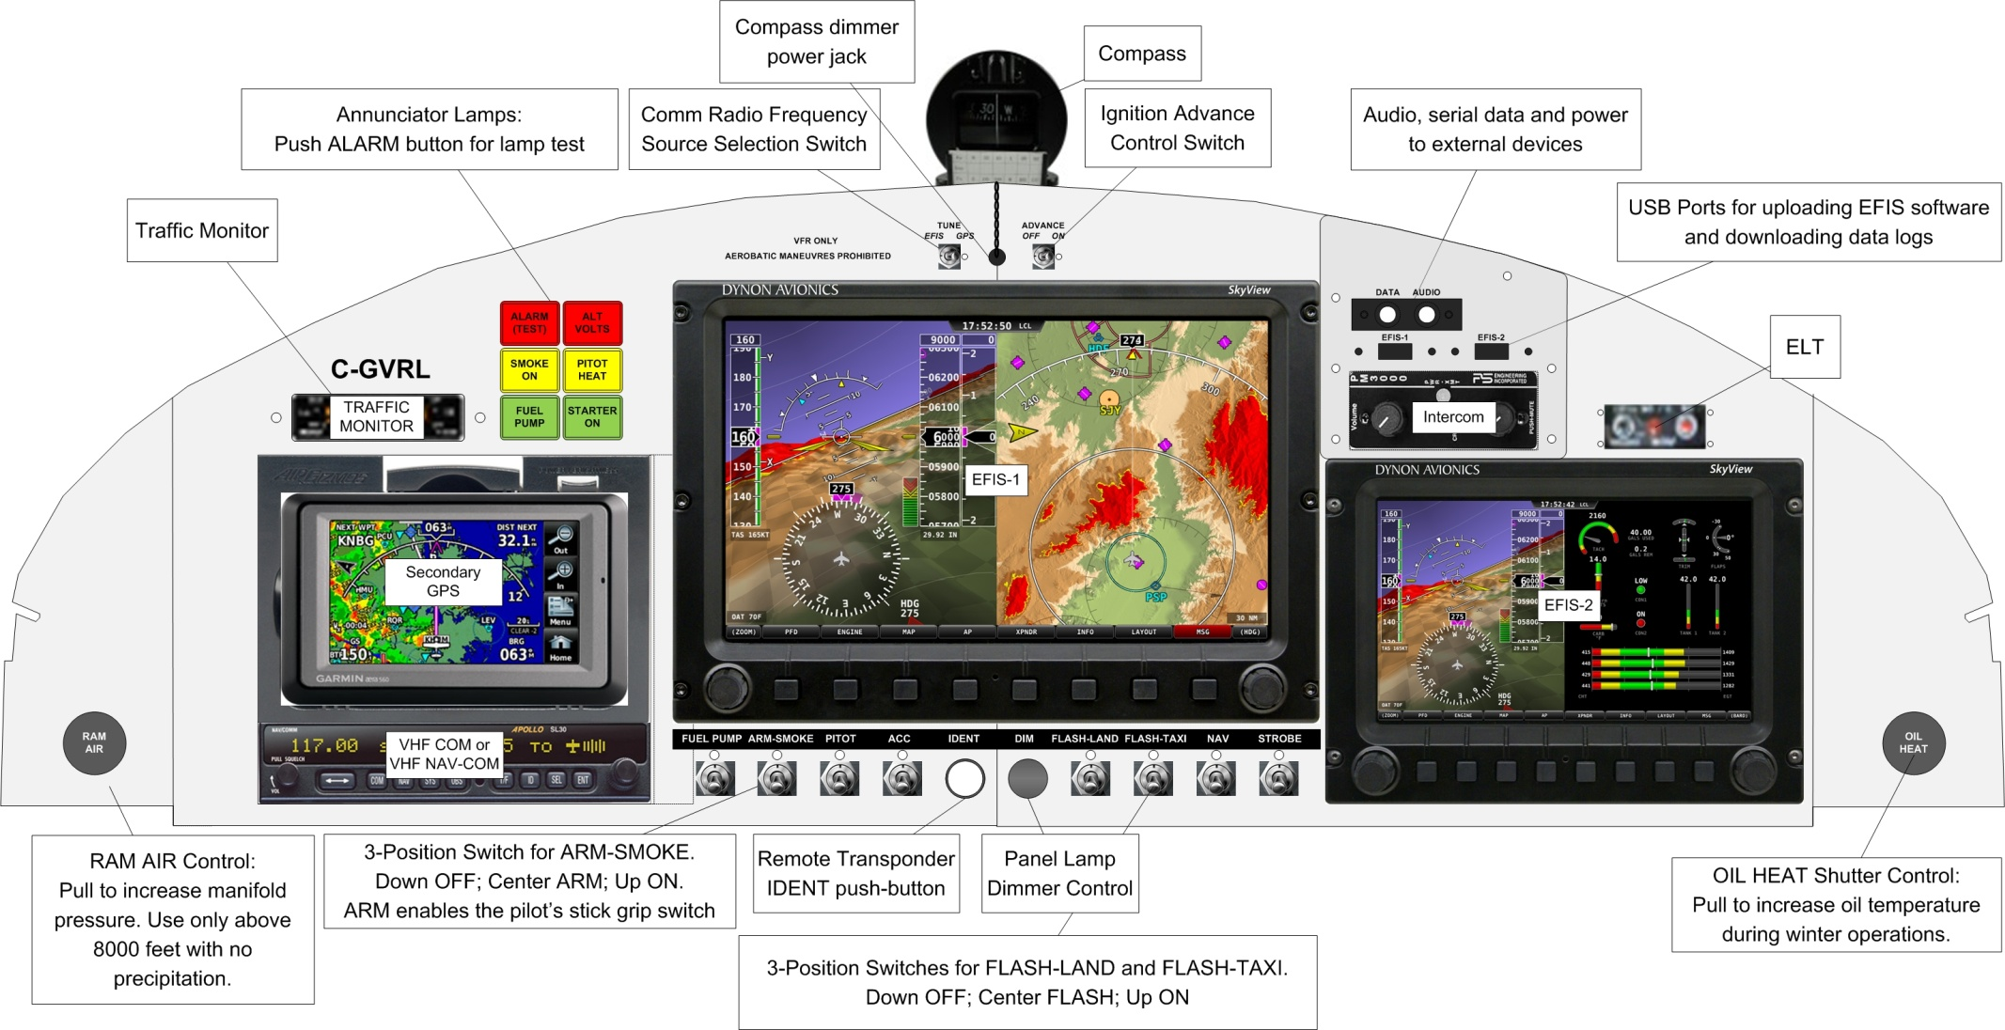

**Panel Right Side:**

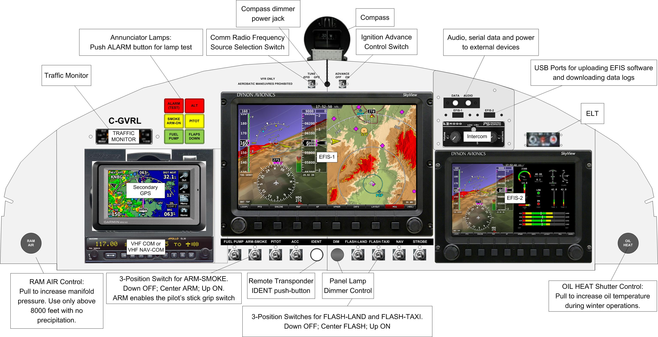

In addition to several conventional self-explanatory switches, instruments and controls, the Instrument Panel supports a few special functions:

* **ANNUNCIATOR PANEL:** These lamps indicate the main fault state (**ALARM (TEST)),** Alternator fault state (**ALT VOLTS**) and various system states (**SMOKE ON** (if installed), **PITOT HEAT** off, **FUEL PUMP** on and **STARTER ON**. Pushing the **ALARM (TEST)** button will cause all lamps to illuminate for lamp testing or panel dimmer adjustment.
* **RAM AIR:** This push-pull control selects the induction air source. When pushed in, warm filtered air from inside the cowling is used. When pulled out, unfiltered ram air from the external cowling scoop is used. ***This control must be pushed all the way in for taxi, takeoff, landing, in dusty conditions, precipitation of any kind or cloud. Do not let ice form on the inlet, as this will prevent the selection of warm filtered air and may lead to engine failure.*** It is highly recommended that this control be left pushed in when the aircraft is stored to prevent foreign objects from entering the induction system. Inspect the cowling scoop during pre-flight for foreign objects and debris.
* **OIL HEAT SHUTTER CONTROL:** This push-pull control selects the position of the oil cooler shutter. When pushed in, maximum airflow through the oil cooler is selected. When pulled out, minimum airflow is selected. This control is normally left pushed in, however, during low temperature operations, pulling this control out will assist in warm-up and keeping the oil temperatures at the proper operating temperature.
* **CABIN HEAT CONTROL:**  This control is located directly below the breaker panel on the panel bulkhead. Pull it out to select cabin heat and push it in to turn off. ***In the event of a fire in the engine compartment, this control must be pushed all the way forward to turn off cabin heat.***
* **GPS SOURCE:** This switch selects which GPS (SkyView GPS puck or Aera GPS) provides the source for the SL-40/SL-30 VHF Com frequency tuning. When the switch is in the SkyView position and if the SkyView EFIS is operating, frequencies from *both* the SkyView and the Aera GPS will be pushed to the SL-40/SL-30 and serial data from the SkyView GPS Puck will appear on the System Access Port. When in the Aera position, only frequencies from the Aera GPS will be pushed to the SL-40/SL-30 and serial data from the Aera GPS will appear on the System Access Port. The GPS SOURCE switch does not affect the SkyView EFIS, which automatically uses the GPS puck (always configured as POS1) as the primary source and the Aera GPS (when configured as GPS1) as the backup source for position information. *Note that the Aera GPS must be configured as GPS1 and not POS2 in order to use as a navigation source on the SkyView EFIS primary flight display.*
* **IGN ADVANCE:** The Right electronic ignition operates with fixed 20 degree advance when this switch is OFF or automatically advances the ignition timing at low manifold pressures when the switch is ON.
* **ALARM push-button:** Pushing this combined lamp/switch will force all of the annunciators to light up, thus simplifying the adjustment of the panel dimmer and testing the annunciator lamp integrity.
* **ARM-SMOKE:** This three-position switch controls the function of the optional Smoke System. In the middle ARM position, control is transferred to the pilot’s control stick SMOKE ENGAGE switch. In the top ON position, the smoke system is always ON, and in the bottom OFF position, the Smoke System is always OFF.
* **ACC:** This switch is used to enable the pilot and copilot seat heaters and the auxiliary 12 Volt power jack Master Bus connection.
* **IDENT push-button:** Pushing this switch will force the IDENT function on the remote transponder without going through the SkyView menu selection. The SkyView EFIS menu selection will still operate normally.
* **DIMMER rotary control:** adjusts the brightness of the panel annunciators, switch legends and compass back light. The SkyView EFIS and SL-30/40 Comm use internal ambient light sensors for automatic dimming. The compass back light power is provided on a power jack directly below the compass. This must be unplugged for panel removal.
* **FLASH-LAND and FLASH-TAXI:** These three-position switches control the landing and taxi lights, respectively. In the middle FLASH position, the lights will flash at a period of about one flash every two seconds. In the top ON position, the lights will be steadily illuminated. When both are in the FLASH position, the taxi and landing lights will flash out of phase. The bottom switch position is OFF for both lights. Note that each wingtip has one landing and one taxi light.

## 12.1 Audio and Data Port Pin Assignments

There are separate 3.5mm 4-wire Audio and Data ports located on the top right of the instrument panel. The Audio port allows the connections of stereo or mono audio sources or cell phones. The Data port provides transmit and receive serial data plus 12 Volt power.

**AUDIO port pin assignments:**

**Function Pin Description**

1. Music Input Left Tip Low-level switched music input, left channel.
2. Music Input Right Ring 1 Low-level switched music input, right channel.
3. Audio Ground Ring 2 Music input virtual ground.
4. Mic Audio Sleeve Phone-compatible pilot’s microphone audio.

**DATA port pin assignments:**

**Function Pin Description**

1. EFIS Serial Output Tip Serial output from SkyView serial port #2. This port is configured to Dynon ADAHRS Serial Data format at 115,200 bits per second and is used by the trim control system to determine the airspeed threshold for trim motor speed control. *Changing the configuration of this port may disable this function.*
2. EFIS Serial Input Ring 1 Serial input to SkyView serial port #2. This input is used by the trim control system. *Do not drive this port with an external device. It is driven by the trim control system.*
3. Power Output (12 V) Ring 2 +12 Volt power, 2.5 amp maximum.
4. Ground System ground.

See the separate Aircraft Electrical System Schematic for more information on connecting external devices to the Audio and Data ports. The audio port is directly compatible with iPod, iPad and iPhone cables. For other devices, a special adapter cable must be fabricated as described in the System Schematic.

## 12.2 Main Breaker Panel

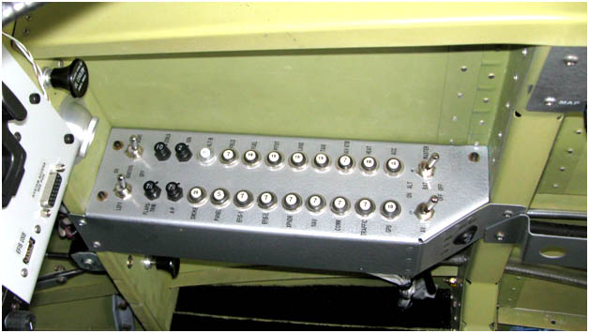

The main breaker panel consists of circuit breakers for the various aircraft electrical systems. There are three main buses: The Master Bus, the Avionics Bus and the Essential Bus that supports the electronic (right) ignition system. There are switches for the Left and Right Ignitions, a Master Switch with Battery only (BAT) and Alternator+Battery (ALT) positions; an Avionics Master switch; and the front seat heater switch. The seat heater only operates when the Instrument Panel ACC switch is ON.

### 12.2.1 Master Bus

When the Master switch is in the BAT or ALT position, the Master Bus is ON. The Master switch in the ALT position also energizes the alternator field circuit. Set the switch to ALT for all flight operations. The BAT position is useful for ground operations to power up the aircraft without energizing the alternator field circuit.

A second function of the Master switch is to disable the starter circuit. Turning the Master to BAT will enable the Starter Engage switch on the pilot’s control stick. Turning the Master to ALT will disable the Starter Engage switch, thus preventing inadvertent operation of the starter motor in flight*. The engine must be started with the Master switch in the BAT position.*  After starting, set the Master switch to the ALT position to enable the alternator and disable the starter.

The following devices are connected to the Master bus:

* Fuel Boost Pump
* Pitot Heater
* Landing Light
* Taxi Light
* Navigation and Strobe Lights
* Seat Heaters
* Accessory Port (12 volt power plug)
* Smoke System (optionally installed)
* Primary SkyView EFIS
* Panel (Intercom & Headsets, Panel Lights and System Access Port power)
* Flaps & Trim Servos
* Autopilot Servos
* Alternator Field

### 12.2.2 Avionics Bus

The following instruments are connected to the Avionics bus, controlled by the AV (avionics) switch:

* Secondary SkyView EFIS
* Remote Transponder
* VHF Comm radio
* Nav radio or Nav section of VHF Nav/Comm
* Traffic Monitor
* Panel Mounted GPS

### 12.2.3 Essential (Ignition) Bus

The Essential Bus is always powered directly from the ignition battery. The ignition coils are powered by the Essential Bus through the COILS circuit breaker, and the ignition controller is powered by the Essential Bus through the IGN circuit breaker in series with the Right ignition switch. *The Essential bus is always live and both the COILS and IGN circuit breakers must be pulled when servicing any component of the right (electronic) ignition system.* The ignition battery circuit is protected by a 15 amp fuse located in the aft battery compartment.

The ignition battery is charged by the main electrical system whenever the Master switch is in the BAT or ALT position. It is intended to sustain the Right ignition system for a few minutes during engine cranking when the Master Bus voltage may drop below 8 volts. It is not intended for long-term powering of the ignition. The connection between the Master Bus and the Essential Bus is made with an isolation diode, which supports both the load current and the ignition battery charging current. This diode also serves as a fusible link in the event of a wiring fault. It is located on the underside of the Main Breaker Panel.

## 12.3 Left Rear Auxiliary Panel Function

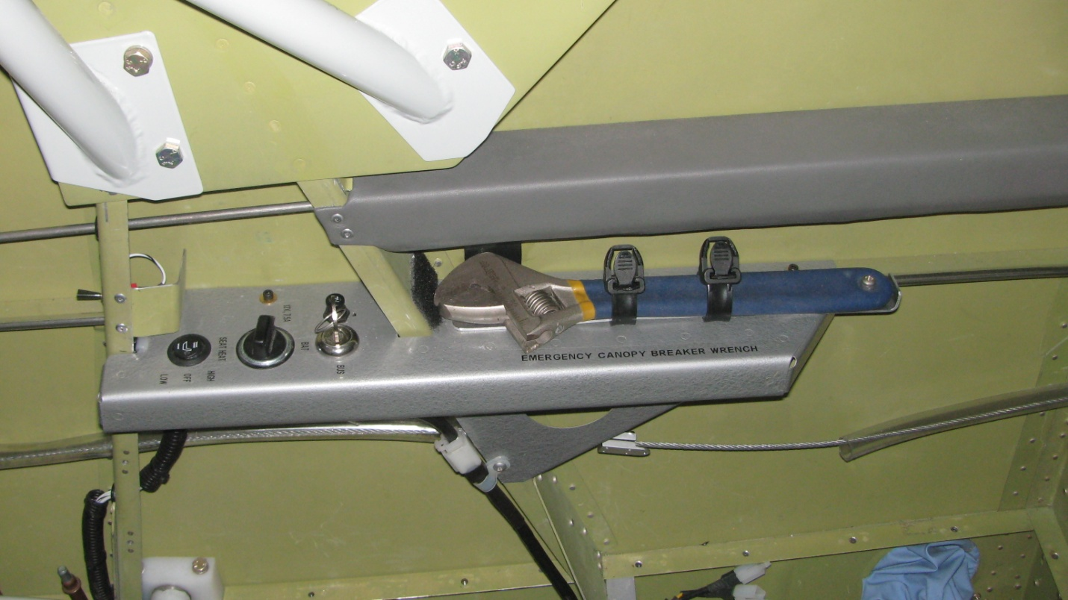

The left rear panel contains a 12 volt automotive power jack, capable of providing up to 7.5 amps of current to an external device. Alternatively, this jack can provide up to 7.5 amps of charging current to the main battery.

A key lock switch is provided to select either the Master Bus for normal accessory operation or the Battery Bus for main battery charging. There is also a three-position switch for the rear seat heater. The seat heater only operates when the Instrument Panel ACC switch is ON.

Mounted on the panel is a modified Crescent wrench that is used as an emergency canopy breaker tool.

## 12.4 Right Rear Auxiliary Panel Function

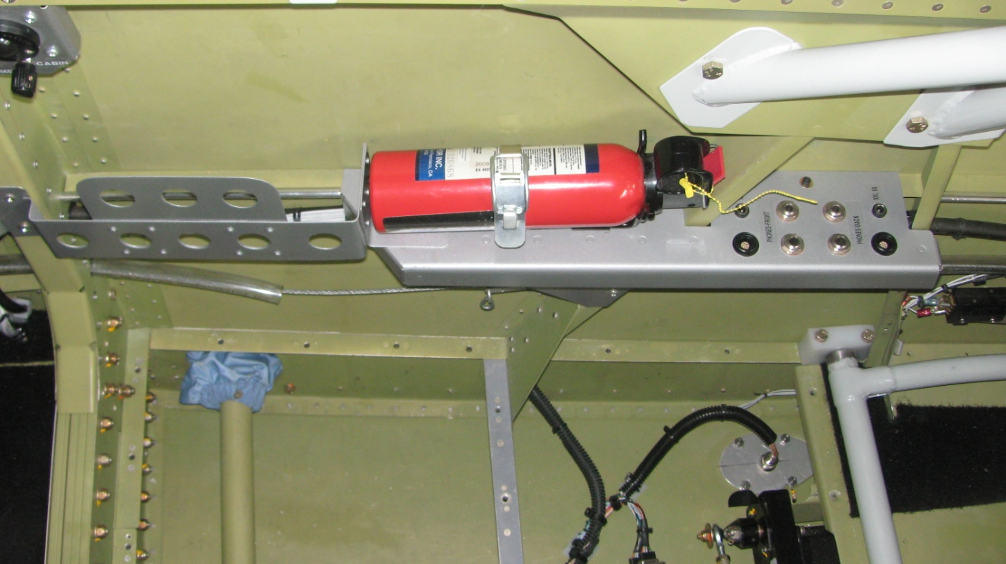

The right rear panel provides front and rear stereo headset jacks. Both conventional aviation-style and Lemo-style jacks are provided plus 10 volt, 1 amp regulated power jacks.

Mounted on the panel is the Fire Extinguisher, which is accessible by the pilot or passenger in flight. Just ahead of the fire extinguisher is a pocket used to hold flight supplements and charts. Located above this pocket is a map light plus two dimmer controls. The forward control is used to adjust the map lights located on both sides of the cabin, and the rear control is used to control the ambient cabin lighting LED strips mounted on the underside of the cabin longerons. *These lights are only active when the Instrument Panel NAV switch is ON.*

## 12.5 Throttle Quadrant

A standard throttle quadrant is provided on the left forward side of the fuselage. The large black grip is the throttle control (push to open, pull to close), the blue knob is the propeller RPM control (push for high RPM, pull for low RPM) and the red knob is the mixture control (push to richen, pull to lean or idle cut-off).

The throttle arm is connected to the aft throttle by a pushrod as shown in the picture. It is acceptable to remove this pushrod for passenger carrying operations.

Quadrant friction is adjusted by turning the knurled knob below the mixture control. Clockwise operation increases quadrant friction, counter-clockwise operation decreases the friction.

On the end of the throttle grip is a secondary flaps control switch. It augments the function of the control stick flaps control. Push upwards on the switch to automatically run the flaps and pitch trim to the take-off preset positions, and push down on the switch to automatically run the flaps and trim down to the landing preset position. Using the throttle grip flaps switch assists primarily in take-off/go-around operations where manual control is difficult when using the main control stick grip switches.

During any adjustment, pushing the opposite throttle grip switch or any control stick trim button will cancel the operation.

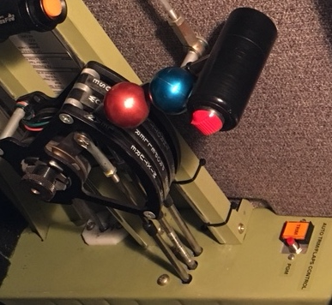 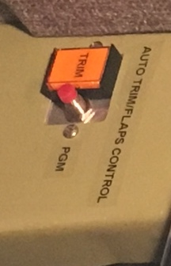

## 12.6 auto Trim/Flaps control Switch & indicator

The aircraft auto-trim/flaps controller uses serial information sent from the EFIS system. The controller provides trim motor speed scheduling; automatic trim control when the EFIS autopilot system is engaged; and flaps and trim preset functions.

Additionally, stuck trim switch timers are used to prevent trim runaway.

The TRIM pushbutton and indicator located forward of the throttle quadrant are used to program and indicate the trim/flaps controller function.

**Normal Operating Modes:**

Manual Mode. The default Manual trim mode works all the time*.* Holding a trim button down too long will engage the button timeout (stuck trim detection) and stop the trim motor from running in the corresponding direction until the button is released/unstuck or other modes are engaged.

Autotrim Mode. With the EFIS operating, the Autotrim Mode automatically engages when the external EFIS datastream indicates valid autopilot commands. The device computes appropriate corrections and makes trim updates every several seconds, as indicated by the TRIM lamp illuminating.

Pressing any trim button will exit the Autotrim mode for several seconds until it automatically re-engages. Disengaging the EFIS autopilot will also exit the Autotrim mode, thus causing the trim function to revert to Manual mode.

Takeoff/Go Around (TO/GA) Mode. With the EFIS operating and airspeed less than VFE, Pressing the throttle grip UP button will cause the TO/GA mode be entered and the TRIM lamp to illuminate. The device automatically positions the flaps and pitch trim to a programmed setpoint, normally the take-off flaps and trim positions.

TO/GA mode is cancelled by pressing any trim button or the throttle grip DOWN button once, or after the flaps and pitch trim have reached their final position. The device then reverts to Manual operation mode.

Landing Mode. With the EFIS operating and the airspeed less than VFE, pressing the throttle grip DOWN button will cause the Landing mode to be entered and the TRIM lamp to illuminate. The device automatically positions the flaps and pitch trim to a programmed setpoint, normally the landing flaps and trim positions.

Landing mode is cancelled by pressing any trim button or the throttle grip UP button once, or after the flaps have reached their final position. The device then reverts to Manual operation mode.

Setpoint Programming. The TO/GA setpoint is programmed on the ground, when indicated airspeed less than 20 knots. The pilot positions the pitch trim and flaps to the takeoff (or go-around) position, then presses the TRIM button until the lamp illuminates, then pushes the throttle grip UP button to store the setpoint. This sets the maximum flaps retraction in TO/GA mode.

Similarly, the Landing mode setpoint is programmed when the pilot positions the flaps to the landing position, presses the TRIM button until the lamp illuminates, then pushes the throttle grip DOWN button to store the setpoint. This sets the maximum flap extension in Landing mode.

**Configuration Modes:**

Pitch Trim and Flaps Polarity. The polarity of the pitch trim direction and flaps direction may be set at initial installation if not already correct. If the stick grip or throttle grip controls works incorrectly, perform the following procedure:

With the aircraft motionless on the ground, extend the flaps all the way down and set the pitch trim all the way nose up. Press and hold the TRIM button down until the lamp illuminates. Continue holding the button down until the light goes off several seconds later. Release the TRIM button to lock in the correct flaps and pitch trim control polarity.

Test the preset function as follows: After performing the flaps and pitch trim programming as described above, position the flaps all the way down and the pitch trim all the way nose up. Press the throttle grip UP button and the pitch trim and flaps should run to the programmed TO/GA position. Then, press the throttle grip DOWN button and the pitch trim and flaps should run down to the preset Landing position.

VFE Setpoint. In flight, VFE is programmed by flying at the VFE indicated airspeed and pressing and holding the TRIM button for several seconds until the lamp turns on. Releasing the button stores the VFE setpoint into permanent memory. This process may be repeated as required, but once set there should be no need to do it again.

The VFE programming also sets the speed scheduling of the trim motors. At speeds less than VFE, the motors speeds are controlled by the A- and B- potentiometers on the device. Above VFE, the motor speeds are controlled by the A+ and B+ potentiometers. See the M-PWR-2AT installation guide for more information.

Troubleshooting. The TRIM lamp will flash at taxi speeds to indicate that the EFIS systems are configured properly, the trim controller is operating and the lamp is functioning. The EFIS systems must be configured to provide *ADAHRS, SYSTEM, and EMS data* at a rate of 115,200 bits per second.

With the EFIS systems configured properly, the normal TRIM lamp flashing pattern is three flashes plus one pause, indicating that the three types of required data sentences are properly received. This helps determine the correct configuration of the EFIS system. Note: at greater than taxi speeds, the TRIM lamp will not flash.

Whenever the EFIS autopilot system is engaged, the trim controller will automatically adjust pitch and roll trim to adjust for gradual changes in aircraft trim due to airspeed changes or fuel imbalance. Auto-trim adjustments that occur when the autopilot is engaged are indicated by brief flashes of the TRIM lamp.

For more information on the trim controller, contact [vern@vx-aviation.com](mailto:vern@vx-aviation.com).

## 12.7 Oxygen System

The aircraft provides the mounting brackets and plumbing for an optional oxygen system. When installed, the oxygen tank/regulator assembly is easily accessible in flight for pilot control of oxygen flow rates. Two self-sealing oxygen jacks are provided for use with oxygen cannula.

To start the flow of oxygen, the tank main toggle valve must be opened and the regulator flow set to the desired rate. It is recommended that a Pulse Oximeter be used to determine blood oxygen saturation levels and the flow rate adjusted accordingly.

The main toggle valve must be shut off at all times when the oxygen system is not in use.

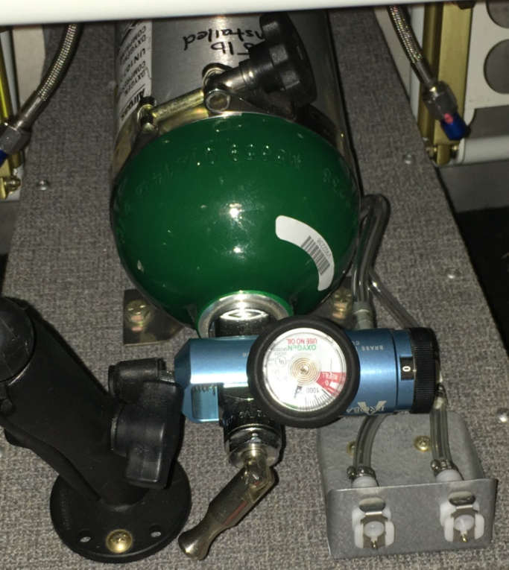

## 12.8 Document Storage

Clips are provided on both sides of the cockpit for storing maps, booklets and other documents.

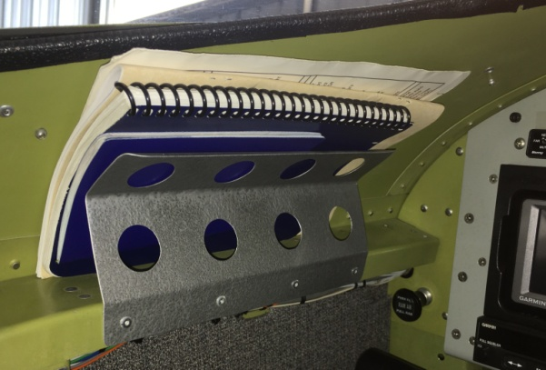

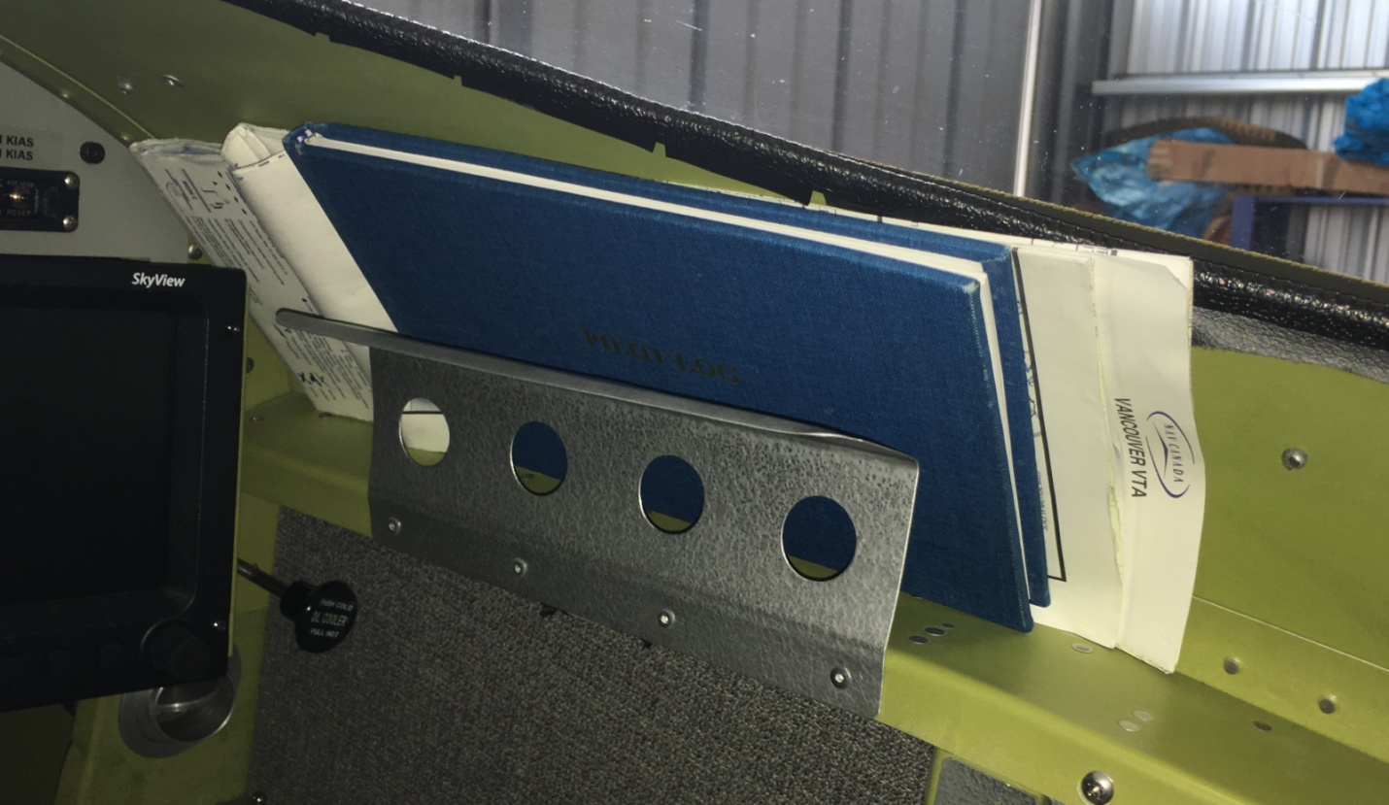

# 13 Control Stick Functions

## 13.1 Pilot Control Stick and Other Functions

The pilot control stick controls many critical aircraft functions. It is important to become familiar with the operation of these functions before flying the aircraft. Of note, the STARTER ENGAGE push-button will be disabled whenever the Master Switch is OFF or in the ALT position. The SMOKE SYSTEM ENGAGE switch is inoperable without the optional smoke system installed. It is enabled whenever the Instrument Panel ARM-SMOKE switch is in the ARM (center) position. The SMOKE SYSTEM ENGAGE switch is a push-on/push-off type.



## 13.2 Passenger Control Stick

The passenger (rear) control stick has only one switch: The push-to-talk push-button switch which is mounted to the top of the stick. The entire stick is removable by unplugging the push-to-talk cable, removing the retention pin and pulling the stick out of the socket. The end of the control stick has been sharpened for use as an emergency canopy breaker tool.

## 13.3 Passenger Throttle, Trim and Rudder Controls

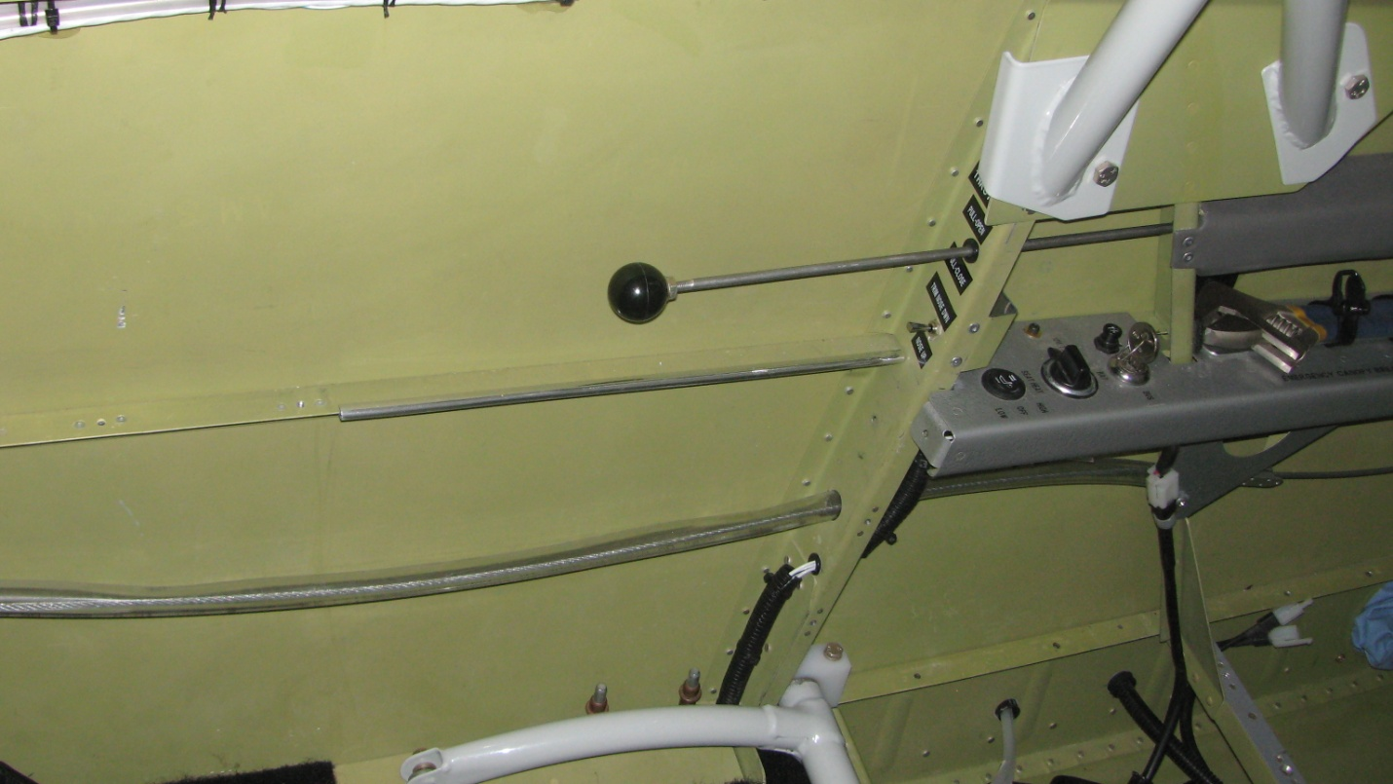

The passenger throttle control is a push-pull rod with a ball-end mounted on the left bulkhead. Directly below the throttle control is the elevator trim control switch. There are also folding rear seat rudder pedals located on the floor boards near the foot wells. The aircraft is not designed for solo flight from the rear seat.

# 14 Emergency Harnesses (Seatbelts)

The aircraft is equipped with 5-point quick-release seatbelt harnesses. Each harness has a rotary Kam Lock assembly that will allow each belt to clip in individually. The Kam Lock assembly is permanently attached to the right lap belt.

To lock the Kam Lock, turn it counter-clockwise. This allows individual belts to be clipped in with automatic engagement. To release the belts, turn the Kam Lock all the way clockwise and pull the belts out.

To tighten the lap and shoulder belts, pull on the loose ends, alternating left and right to keep the Kam Lock low and centered. To loosen the shoulder belts, pull upwards on the red tabs. To loosen the lap belts, tilt up the silver adjustment buckles and pull upwards.

It is important to adjust the seatbelts to ensure that the lap belt is low and tight around the hips. Tighten the lap belt and center the Kam Lock before tightening the shoulder harness. The anti-submarine belt does not have to be fully tightened.

For aerobatic operations, all belts must be as tight as possible.

# 15 Engine Starting Procedure

## 15.1 Cold Starts

1. FUEL PUMP OFF
2. AV MASTER OFF
3. Ram air control IN
4. Oil Cooler as required
5. Select required fuel tank
6. Throttle CLOSED, propeller HIGH RPM and mixture full lean (idle cut-off)
7. MASTER to BAT, FLAPS RETRACT, FUEL PUMP ON
8. Throttle wide open, mixture to full rich approximately 5 seconds
9. Propeller control maximum RPM
10. Throttle closed, mixture full lean (idle cut-off)
11. FUEL PUMP OFF
12. Throttle open 1/4”
13. IGNITION, both ON
14. STROBE ON
15. Brakes ON, Clear Prop
16. STARTER ENGAGE
17. Mixture slowly to full rich
18. Throttle 1100 RPM
19. Check oil pressure gauge. If minimum oil pressure is not indicated within thirty seconds, stop engine and determine trouble.
20. MASTER to ALT

## 15.2 Hot Starts

1. FUEL PUMP OFF
2. AV MASTER OFF
3. Ram air control IN
4. Oil cooler as required
5. Select required fuel tank
6. Throttle closed
7. Propeller maximum RPM
8. Mixture full lean (idle cut-off)
9. ELECTRICS OFF, MASTER to BAT, FLAPS RETRACT
10. Mixture full rich
11. Throttle wide open until the fuel pressure drops then throttle closed.
12. Mixture full lean (idle cut-off)
13. Open the throttle 1/4”
14. IGNITION, both ON
15. STROBE ON
16. Brakes ON, Clear Prop
17. STARTER ENGAGE
18. While starter is engaged, slowly advance throttle until engine starts.
19. Mixture promptly to full rich
20. Throttle 1100 RPM
21. Check oil pressure gauge. If minimum oil pressure is not indicated within thirty seconds, stop engine and determine trouble.
22. MASTER to ALT

# A1 Emergency Procedures

The pilot must be familiar with the following emergency procedures before commencing flight operations.

## A1.1 Airspeeds for Emergency Operations (KIAS)

**VBG Best Glide 87**

**VX Best Angle of Climb 74**

**VY Best Rate of Climb 91**

**VREF Short Field Landing 65**

## A1.2 Emergency Egress

In the event of a flip-over, the **Emergency Canopy Breaker Wrench** is used to break through the canopy.



Press the knurled tabs on the hold-down straps and pull them away from the sidewall to release the wrench. The wrench tips and heel are sharpened to facilitate scoring a large ‘X’ in the Plexiglass canopy. Use a firm grip on the wrench to punch through the canopy at the center of the ‘X’. Finally, adjust the jaws of the wrench to grasp the sharp edges of the Plexiglass and snap off pieces as required to gain a safe egress.

## A1.3 Alternator Failure

If the main alternator fails, the **ALT** warning light will illuminate and a low voltage warning will appear on the EFIS and Traffic Monitor. The alternator is protected by a 60 amp B-bus breaker and a 7 amp Field breaker. It is permissible to reset either of these breakers once in flight. If the fault continues, it is advisable to land the aircraft as soon as possible.

A minimum of one hour of backup power is provided by the main battery, plus an additional one hour backup provided by the EFIS battery and the internal battery of the GPS unit. The battery for the right electronic ignition is not designed to last more than a few minutes after the main battery is discharged. Without electrical power, the engine will continue to run utilizing the left magneto and engine driven fuel pump but in order to prevent fuel starvation, HIGH THROTTLE SETTINGS MUST BE AVOIDED as well as high angles of attack.

## A1.4 Electrical System Loads

**Normal Loads:**

* Battery Contactor 0.7 amp
* EFIS Dynon SkyView SV-D1000, SV-D700 3.5 amp each x 2
* EFIS Battery Dynon SkyView SV-BAT 1.5 amp when charging.
* GPS Garmin Aera 500 0.2 amp
* Com Garmin SL-40 (or Com portion of SL-30) 0.3 amp
* Nav Garmin SL-30 (optional) 0.6 amp
* Transponder Dynon SV-XPNDR-262 0.4 amp
* Traffic ATD-300 0.1 amp
* A/P Servos Dynon SkyView 1.3 amp each x 2
* Intercom PS Engineering PM3000 0.2 amp
* Ignition Electroair <2 amp

**Intermittent/Discretionary Loads:**

* Heated Pitot Dynon < 10 amps
* Position Lights 1 amp
* Landing Lights 14 amp
* Taxi Lights 14 amp
* Strobe Lights 1 amp
* Flaps 5 amp
* Trim 0.3 amp
* Cockpit Lighting < 0.3 amp
* Com (transmit) SL30/SL40 3 amps
* Fuel Boost Pump AirFlow Performance 6 amps
* Smoke System 10 amp
* Seat Heaters 7 amp each x 2

## A1.5 Emergency Procedure Checklists

